Renal/ GI/ Nutrition Module- Spring 2014

Nicole M. Sifontis, Pharm.D.

Clinical Professor
Office: Room 135B

Phone: 215-707-4922
Email: Nicole.sifontis@temple.edu
Office hours: Mondays 2:00 - 3:00 PM
Thursdays 12:00-2:00 PM or by appointment

Viral Hepatitis

Educational Outcomes:

After attending this lecture, completing the required reading assignment and working through the cases in class, the student should be able to:
- Define viral hepatitis and state the various types that commonly occur
- Be familiar with hepatitis nomenclature particularly relating to HBV and HCV
- Be familiar with the epidemiology, transmission and risk factors as well as the pathophysiology of HAV
- Outline the clinical course and manifestation of HAV
- Discuss the management of HAV, both prophylaxis and treatment.
- Be familiar with the natural history, epidemiology, transmission, risk factors, virology and pathophysiology of HBV
- State the goals of therapy for treatment of HBV
- When given a patient case the student should be able to provide patient-specific drug therapy recommendation for treatment of HBV. This therapeutic plan should include drug, dose, route, duration of therapy and monitoring for efficacy and safety for the following agents:
- IFN, Peg IFN, lamivudine, adefovir, telbivudine, entecavir and tenofovir
- Be familiar with the natural history, epidemiology, transmission, risk factors, virology and pathophysiology of HCV
- Compare the two pegylated interferon products
- When given a patient case the student should be able to provide patient-specific drug therapy recommendation for treatment of HCV. This therapeutic plan should include drug, dose, route, duration of therapy and monitoring for efficacy and safety for the following agents:
- Peg-IFN, ribavirin, telaprevir, boceprevir, simeprevir and sofosubir
- Evaluate the role of the clinical pharmacist in optimizing care for patients at risk for and/ or infected with viral hepatitis.

Required reading assignment
Pharmacotherapy: A Pathophysiologic Approach. 8th edition, Chapter 47.

- History 1:35
- Viral hepatitis refers to the clinically important hepatotrophic viruses responsible for :
- hepatitis A (HAV)
- hepatitis B (HBV)
- hepatitis C (HCV)
- delta hepatitis (HDV)
- hepatitis E (HEV) and
- A sixth virus, hepatitis G (HGV) has emerged and is currently being investigated

- Currently, viral hepatitis affects more than 500 million people and remains a significant public health treat worldwide

- Viral hepatitis may present as either acute 4:10
  - Discrete date of onset
  - Rarely exceeds 6 months
  - a/w jaundice and AST/ ALT >2.5 x ULN

- Or chronic
  - Inflammatory condition with biologic, virologic and histologic changes for more than 6 month
  - HBV, HCV and HDV are risk factors

Hepatitis A virus (HAV) 9:00

- Epidemiology 10:40
- About 1.4 million cases of hep A occur worldwide annually
- Outbreaks have occurred in every decade since 1960 with the last one in 2003 in Pennsylvania
- According to the CDC there were 2,979 cases reported in 2007
- About 11-22% of those infected with HAV require hospitalization

- Etiology
- Small non-enveloped single stranded ribonucleic acid (RNA) virus belonging to the hepatovirus genus of the picornaviridae
- Humans are the only reservoir for the virus

- Transmission and risk factors
- Fecal-oral route
- Ingestion of contaminated food or water
- Conditions in which transmission is more likely to occur include International travel to countries with high rates of hepatitis A, poor conditions and hygiene and overcrowded areas
- Others at risk include health care workers, IV drug users using unsterilized needles, food service handlers and those in health-care institutions
- Pathophysiology 13:32
- HAV's life cycle in the human host classically begins with ingestion of the virus. Absorption in the stomach or small intestine allows entry into the circulation and uptake by the liver. Replication of the virus occurs within hepatocytes and gastrointestinal epithelial cells
- Once the HAV enters the hepatocyte, the RNA strand translates into a polyprotein, producing a template to replicate more RNA and causing more virions to be produced
- As part of the viral degradation process, the HAV is released into the biliary system causing elevated concentrations of the virus in the feces, therefore explaining its endemic potential in underdeveloped parts of the world
- Enterohepatic cycle will continue until antibody neutralization
- Self limiting disease
- Low case fatality
- Rarely leads to fulminant hepatic failure
- No chronic liver disease has been associated with hep A

EVENTS IN HEPATITIS A VIRUS INFECTION 15:00

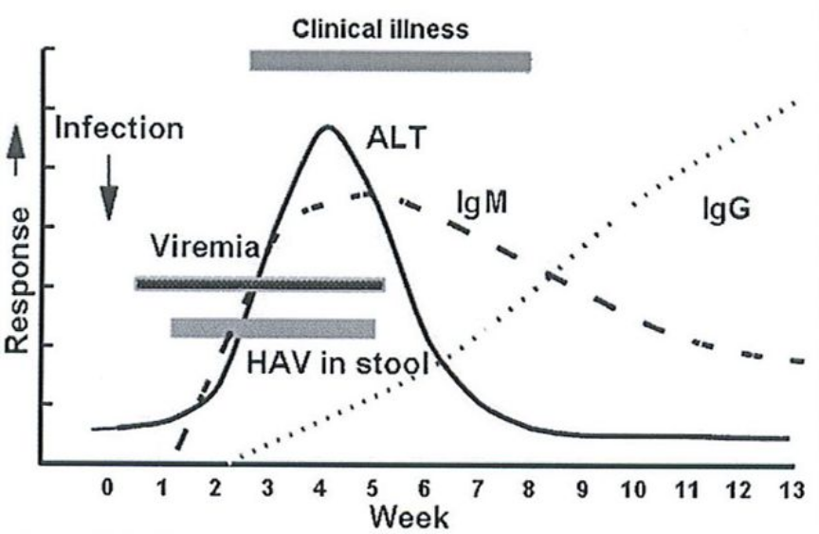

- Diagnosis and serologic testing 20;00

- Diagnosis may be difficult because most patients are asymptomatic
- Definitive test is the detection of immunoglobulin (Ig) antibody to the capsid proteins of HAV (anti-HAV)
- Acute infection is indicated when IgM HAV antibody (anti-HAV) is present in serum about 3 weeks after exposure, levels become undetectable within 6 months
- Liver biopsy not routinely done

- Management 21:54

Prophylaxis
- Good hand washing and personal hygiene practices

- Travelers to endemic areas should avoid uncooked meat, shellfish, uncooked fruits and vegetables, avoid drinking water of unknown purity

- Definitions: 24:00
  - Pre exposure prophylaxis- primarily done by vaccination

- Post exposure prophylaxis- recommended for those who are in contact with a person with acute viral hep A such as household and sexual partners, staff and children from day care facilities and food handlers of restaurants

- Hep A vaccine (VAQTA® (preservative free) and Havrix®) 25:11

- Inactivated virus which provides active immunity and long-term protection

- Routine vaccination (2 doses, or 4 doses combined Hep A & Hep B vaccine):
  - for all children 12 to 23 months of age (routine childhood immunization schedule)
  - international travelers to endemic areas (South and Central America, Africa, South and Southeast Asia and the Middle East)
  - MSM, IVDU, HIV infected individuals
  - individuals with chronic liver disease

Recommended Dosing of Havrix and Vaqta

Vaccine | Age (y) | Dose | No. of Doses | Schedule (mo)
Havrix | 1–18 | 720 ELISA units | 2 | 0, 6-12
 | 19 | 1,440 ELISA units | 2 | 0, 6–12
Vaqta | 1–18 | 25 units | 2 | 0, 6–18
 | 19 | 50 units | 2 | 0, 6–18

- Seroconversion rates >94% are achieved with the first dose but booster dose recommended with both brands to achieve highest possible antibody titer.
- Both brands are interchangeable for booster shots

- Serum immune globulin (IVIG) 30:30
- IVIG from pooled human plasma
- Given IM it provides passive immunity by transfer of antibodies against hep A
- Does not provide long-lasting immunity
- IVIG is recommended for post-exposure prophylaxis
Treatment 32:40
- No specific treatment because it is a self-limiting disease

- Supportive
- Healthy diet, rest, adequate fluid intake, avoiding hepatotoxic drugs and alcohol
- Most patients recover within 10 weeks
Key Points 35:40
- Hep A is a highly infectious yet self-limiting disease
- Transmission by fecal-oral route
- Prevention is the best cure
- Hep A vaccine (part of childhood scheduled vaccinations) preferred for pre-exposure prophylaxis and post exposure prophylaxis is those between the ages of 2 – 40 years old who are immunocompetent
- IVIG + Hep A vaccine is recommended for
  - post exposure prophylaxis in those younger than 2 years of age and
  - post exposure prophylaxis in those > 40 years old
  - immunocompromised individuals with liver disease
- Supportive treatment (no role for antiviral therapy)

Hepatitis B virus (HBV)

- History 37:30
- First discovered in 1947 by F.O. MacCallum who noticed a trend of individuals developing hepatitis from blood transfusions
- 1963: the antigen was discovered in an aborigine. This antigen is now known as the hep B surface antigen (HBsAg)
- 1967: association between the antigen and the development of hepatitis was confirmed
- 1972: laws passed in the US requiring all donated blood be tested for Hep B by screening for HBsAg
- With this legislation, the incidence of hep B decreased and when the hep B vaccine became available in 1981 the incidence declined further. Nevertheless, the disease continues to be a worldwide problem.

- Natural history 38:30
- Most individuals who have been infected with HBV recover and develop anti-HBs resulting in life long immunity
- However, 2% may develop acute infections leading to fulminant hepatitis which is associated with a 60-90% mortality rate
- About 15% will develop chronic hep B (CHB)
  - Of this population the chance of developing CHB is <20% if patients were infected during adult age
  - Risk of chronic infection increased to more than 40% if the infection occurred perinatally

- Epidemiology
- According to the CDC only 12% of the global population live in an area of low prevalence for hepatitis B
- Hep B is a worldwide infection affecting more than 2 billion individuals, including 350-400 million who are chronically infected
  - more than 1.25 million cases occurring in the United States. Of these individuals 50-70% was born outside the United States.
  - CHB accounts for 2,000-4,000 deaths/ year
- Epidemiological studies have shown that the prevalence of hep B differs geographically:
- About 75% of the worlds 400 million people with CHB live in Asia
- Southeast Asia infection rate occurs during perinatal and childhood years at a rate of 10-15%. These areas have yet to or only recently implemented hep B vaccination programs, eg in China, with a total population of more than 1.6 million, immunizations were initiated in 2000 and in the Philippines, only 30-40% of the population have been vaccinated
- Rate of CHB in North America and Western Europe is about 1%

- Transmission and risk factors 40:50
- Spread by contact with blood, semen and other body fluids of an infected person
- Sexual, parenteral (IVDU) and perinatal transmission
  - Perinatal (most common mode of transmission in areas of high prevalence)- South East Asia
  - Sexual and parenteral modes of transmission most common in the United States
- High risk groups include IV drug users, multitransfused patients, health care providers, male homosexuals, heterosexuals partners of HBV infected people, heterosexuals partners of HIV infected individuals

- Etiology 43:20
- HBV is the smallest known DNA virus
- It is a envelop, double stranded DNA virus belonging to the hepadnaviridae family
- This family of viruses replicate in the liver and cause hepatic dysfunction that can lead to chronic hepatitis, cirrhosis and hepatocellular carcinoma (HCC)

- Pathophysiology 44:20
- HBV is not directly cytopathic; instead it is thought that the immune response to the virus is cytotoxic to hepatocytes.
- Cytotoxic T cell killing of infected cells occurs due to immunologic response to get rid of infected cells.
- Chronic HBV is a function of poor cytotoxic T cell response to viral antigens.
- Cirrhosis results as the liver attempts to regenerate while in an environment of persistent inflammation
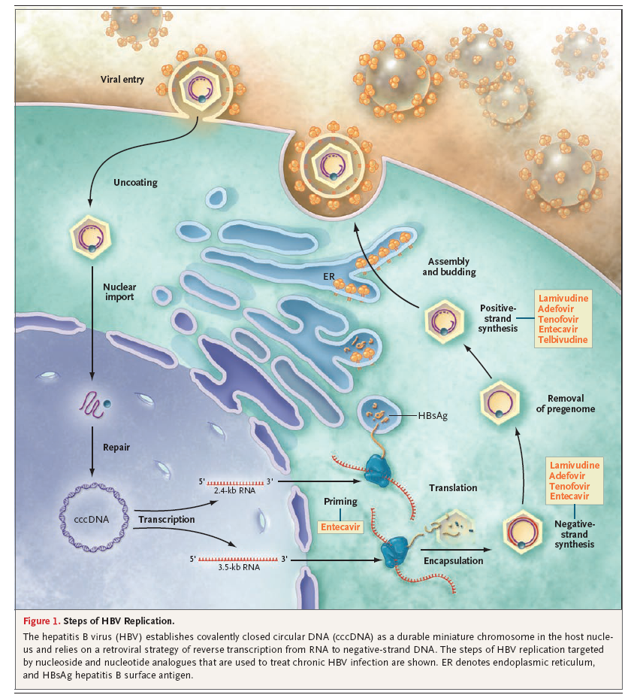
Adapted from Dienstag JL. NEJM 2008;359:1486-50

- Hep B viral replication is a complex mechanism involving several steps:
- first step is called fusion where the virus must attach and enter the host hepatocytes
- once inside the nucleus the HBV DNA polymerase starts repairing the gap in the (+) strand to form a covalently closed circular DNA (cccDNA) which is how HBV persists in the cell
- viral transcription occurs when RNA from the host produces a template for viral DNA production
- In the next step the translation forms viral proteins including HbsAg, HbcAg and HbeAg
- With the production of viral cores, assembly of the virus occurs by packaging the RNA in the cytoplasm
- Next reverse transcriptase allows the synthesis of RNA to negative strand DNA
- Finally, viral replication is complete when mature, infectious virions are released into the blood
- Total eradication of virus is rarely seen
- Interpretation of HBV Markers

HBsAg  (Hepatitis B surface antigen) | First marker of active infection  Major viral protein found in serum  Chronic infection is indicated if levels persist >6 months
anti-HBs (Hepatitis B surface antibody) | Indicates recovery and immunity to HBV infection  Absent in chronic infection.  Positive in a person who has been successfully vaccinated against hepB
HBcAg (Hepatitis B core antigen) | Encloses the viral DNA and essential for viral packaging  Not detectable in serum, only in liver tissue with acute or chronic HBV
anti-HBc (total Hepatitis B core antibody) | Found in acute and chronic carriers  Utilized as a marker for past infection  Also used as an antibody to distinguish between previous infection and vaccination  Never appears in those vaccinated and almost always is present in previously infected individuals
HBeAg | Found in serum during acute and chronic hepatitis B  Presence indicates viral replication  Generally associated with a high degree of infectivity
Anti-HBe | Important in determining seroconversion
HBV DNA | Presence is a marker of viral replication and high infectivity

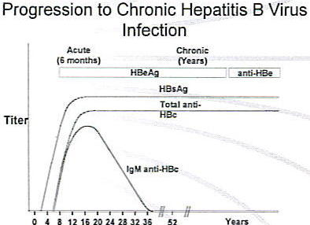
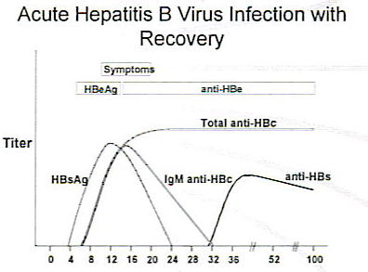

- Management
Prophylaxis 8:20
- Hep B vaccine (Recombivax HV® and Energix-B®)
- Indicated for:
  - all children in the United States.
  - patients with CKD/ ESRD, health care workers and public safety workers exposed to blood or other infectious body fluids
  - sexually active individuals with multiple sex partners. IVDU, inmates of long-term correctional facilities, MSM, patients with chronic liver disease
- Vaccine neutralizes HbsAg in >95% of people
- 3 dose regimen: time 0, 1-2, and 4-6 months
- Most common side effect a/w the vaccine is injection site reactions
- Twinrix (Hep A and B vaccine): New schedule: time 0, 7 and 21-30 days then a dose @ 12 months

- Treatment 12:30. Don’t memorize. Just know S/E
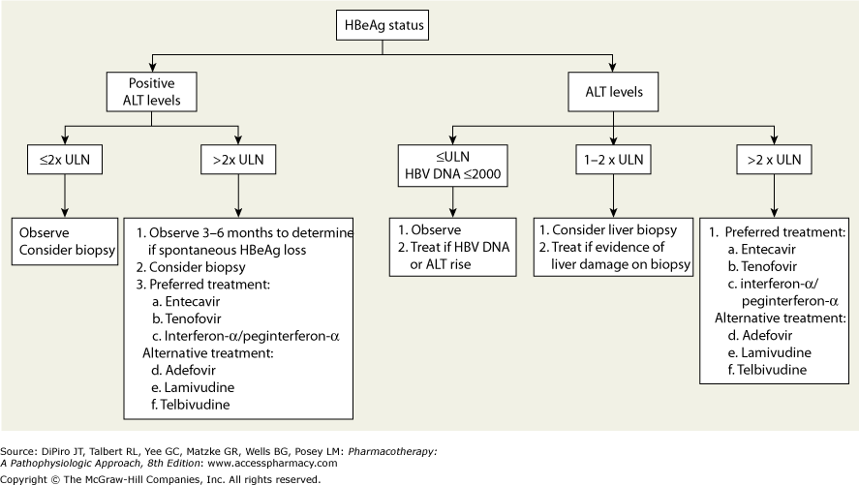
- Two modes of treatment
- Immunomodulation- IFN/ pegylated interferon
- Viral suppression-nucleos(t)ide analogues (lamivudine, adefovir, entecavir, telbivudine, tenofovir)

Comparison of agents for the treatment of CHB 15:40

Feature | Interferon | Lamivudine (Epivir-HBV®): | Adefovir (Hepsera®) | Entecavir (Baraclude®) | Telbivudine (Tyzeka®) | Tenofovir (Viread)
MOA | Endogenous cytokine that induces the immune system to exert antiviral activity  Immuno-modulator | Nucleoside analog  Reverse transcriptase inhibitor | Acyclic nucleotide analog  Reverse transcriptase inhibitor | Guanosine nucleoside analog  Reverse transcriptase inhibitor  30 x > potent than lamivudine | Nucleoside analog  Reverse transcriptase inhibitor  Higher antiviral potency than lamivudine | Nucelotide analog  Reverse transcriptase inhibitor  Higher antiviral potency than adefovir
Dose | Weekly | 100 mg daily | 10 mg daily | 0.5 mg PO daily | 600 mg PO daily | 300 mg po daily
Route | SQ | Oral | Oral | Oral | Oral | Oral
Duration of therapy | Finite (12 months) | Indefinite (yrs to life) | Indefinite  (yrs to life) | Indefinite  (yrs to life) | Indefinite  (yrs to life) | Indefinite (yrs to life)
Side-effects | Flu-like syndrome Fever, chills, myalgias  ↓ WBC, ↓ Plts  Depression, suicidal ideation | N/V, HA, fatigue | Nephrotoxicity, lactic acidosis | HA, GI upset | Myopathy, peripheral neuropathy | GI upset,
Feature | Interferon | Lamivudine (Epivir-HBV®): | Adefovir (Hepsera®) | Entecavir (Baraclude®) | Feature | Interferon
Monitor | Weekly CBC during first 2 weeks then monthly  LFTs at baseline and every 3-6 months during therapy | Renal dose adjustments | Renal dose adjustments | Minimal | Minimal | Renal dose adjustments
Viral resistance | None | 15-30% @ 1 year  70% @ 5 years | None @ 1 year  Approx 30%@ 3 years | Low | High? | Unknown
Cost | High | Low | Intermediate | Intermediate | Intermediate | Intermediate
Place in therapy | Finite treatment duration, no resistance  Low tolerability  Not recommended in decompensated disease | Third line  Low cost, low side-effect profile  Moderate potency  High rate of resistance | Second line  Least potent  Slowest to suppress HBV DNA levels  Most likely to result in primary nonresponse | First line  High potency, low resistance  First line in most protocols | Second line  Place in therapy unknown  High potency  High resistance? | First line  High potency  Likely to replace adefovir in therapy

Summary 31:30

- Indefinite treatment with oral agents
- Seroconversion higher with peg interferon (max 1 year of treatment) compared to any oral agent. However, SE of IFN limits its use.
- Use of oral agents have been lifesaving in HBV infection, paralleling a 30% reduction in the number of patients listed for liver transplant annually in the US
- Decompensated cirrhosis- oral agent is only option
- Entecavir or tenofovir considered first line treatment options
- Tenofovir most likely to be used in patients with HIV coinfection since it is active against HIV

- Overall goals of therapy 35:00
  - Prevent disease progression to cirrhosis, hepatocellular carcinoma (HCC)
  - Minimize further injury in patients with ongoing liver damage

General Monitoring Parameters

- HBV DNA at start of therapy, every 6 months initially and then annually once stable

- Aminotransferase (AST/ALT, Tbili) every 3 to 6 months in conjunction with clinical monitoring for decompensation (refractory ascites, hepatic encephalopathy, varices)

Key points 36:30
- HBV has a high incidence worldwide
- Only 15% develop chronic infection
- Vaccination recommended for prophylaxis
- HbsAg, HbeAg and HBV DNA are reliable markers for infectivity
- IFN/ Peg IFN limited by cost and side effect profile
- Lamivudine/ telbivudine limited by resistant HBV mutants
- Adefovir limited by potency
- Entecavir/ tenofovir- first line therapy

Future Treatment Options for Chronic Hepatitis B infection

- Emtricitabine
  - Nucleoside analog approved for treatment in HIV

- Pradefovir
  - Prodrug of adefovir
  - Developed to circumvent toxicity a/w adefovir

Sample Exam Question

- What does the presence of hep B surface antigen (HBsAg) indicate
  - The patient has been vaccinated against HBV
  - The patient has acute or chronic HBV and is infectious
  - The patient had an acute HBV infection and cleared the virus

- A 48 year old gentleman with HIV and chronic hepatitis B infection presents to the GI clinic to begin treatment.

Current meds: none
Physical exam: AA&O x 3, no ascites. (no decompensated)
Serologies: HbsAg (+), HbeAg (+), anti HBs (-), HBV DNA >1,000,000 copies/ml, HIV positive

Which of the following is the best pharmacotherapy plan to treat this patient’s chronic hepatitis B infection?

- Initiate entecavir 1mg po daily (no b/c use lower dose)
- Initiate tenofovir 300mg po daily (first line + HIV)
- Initiate telbivudine 600mg po daily (no b/c second line)
- Initiate Peg- IFN SQ once weekly (no b/c side effects and affects HIV)

Hepatitis C virus (HCV) 9:30

- Natural History
- Formally known as non A non B hepatitis
- Morbidity associated with hep C is a significant burden on the health care cost
- The increased cost is because of hep C developing into a chronic disease in more than 85% of the cases, the rest develop acute hep C which resolves without sequelae
- Approximately 20% develop cirrhosis
- Progression to cirrhosis take up to 20-40 years from time of exposure to advance from fibrosis and cirrhosis
- Factors contributing to the development of cirrhosis include alcohol use, gender, infection at an older age and coinfection with HIV and HBV.
- Rate of developing HCC increases 1-4% per year when cirrhosis is confirmed

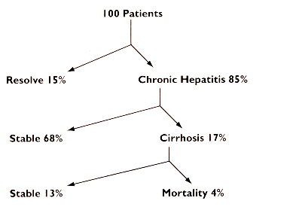

- Epidemiology 15:00
- In the United States, HCV is the most common blood-borne infection
  - it is estimated that 3.2 to 5.2 million people in the US are chronically infected with Hep C (170 million worldwide; 2.5% of world’s population)
  - 35,000 new cases of HCV documented annually (85% become chronic)
  - 10,000 to 12,000 HCV related deaths occur per year
  - 3.27% of baby boomers have been exposed to Hep C
  - cirrhosis caused by HCV is one of the primary reasons for liver transplant in the US

- Global Disease Burden/ # of chronic cases
  - HBV- 370 million
  - HCV- 170 million
  - HIV- 40 million
  - HIV/ HBV- 3-4 million
  - HIV/ HCV- 4-5 million

- Chronic Hep B and Hep C in the United States
  - Hep B- 2 million
  - Hep C- 3.5 million

- Transmission and risk factors
- Spread by blood to blood contact with blood of an infected person: healthcare workers may be at risk, sharing contaminated needles to inject drugs, tattoos, transmission by an infected mother to her newborn during birth.
- Spread by blood transfusions before 1992 or clotting factors received before 1987
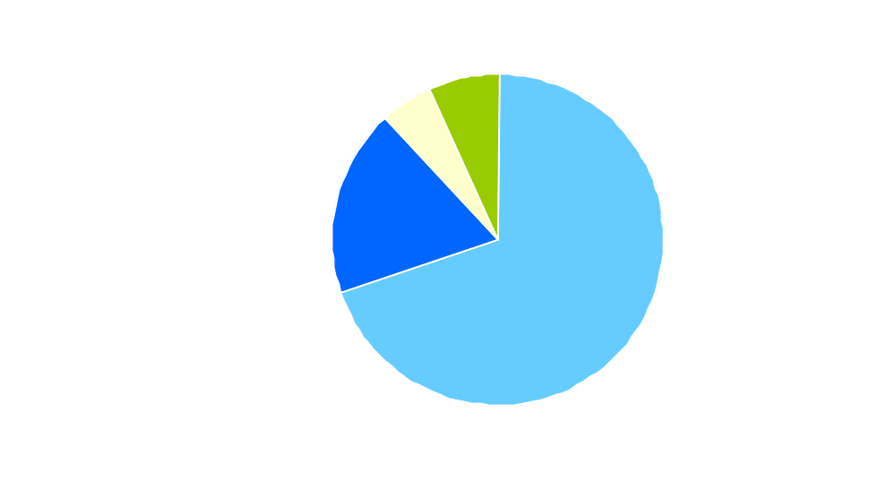

- Pathophysiology
Life cycle of Hepatitis C virus. Adapted from Nature Reviews Drug Discovery 2007;6:991

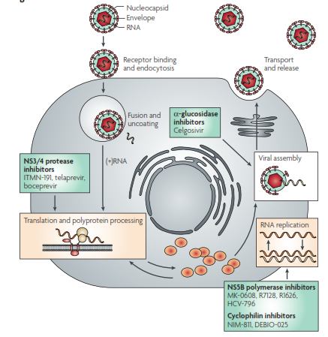

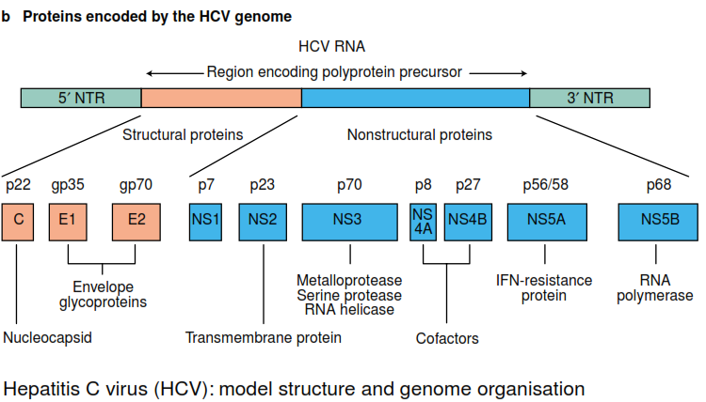

- Small positive strand RNA virus that almost exclusively infects hepatocytes
- Virus replicates in hepatocytes but is not directly cytopathic 22:00
- When virus enters a liver cell it releases its RNA and is translated into a poly-protein containing structural and nonstructural regions
- Poly-protein is processed by proteases into several polypeptides with different functional roles in the virus life cycle. The nonstructural region codes for the polypeptides NS2, NS3, NS4A
- , NS4B, NS5A and NS5B. All potential targets for drug therapy. Initial cleavage is performed by NS3/NS4A protease which is prevalent across most strains and without which the HCV life cycle cannot proceed.
- The virus is replicated with the help of a polymerase and then assembled, transported and released from the cell.
- Persistent infection is largely due to inadequate humoral and cellular response. This intermediate response is large enough to induce hepatic cell destruction and fibrosis but not enough to eradicate the virus from its reservoirs
- Unlike HIV and HBV, the HCV genome is NOT maintained IN the host cell nucleus in any durable form, it only exists as a cytosolic RNA. Therefore clearance of infection from the cell without destruction of the cell should be possible. The term “cure” is now used in patients with chronic hepatitis C who achieve a SVR and clear the virus.

- Virology 29:00
- Six identifiable genotypes and more than 90 subtypes identified
- Genotypes numbered 1 to 6 and further divided into subtypes 1a, 1b, 2a or 2b
- In the United States about 75% of those infected with HCV have either genotype 1, followed by 14% for genotype 2
- Function of genotype is to determine the likelihood of therapeutic response.
- Genotype 1 is most resistant to therapy

- Clinical Course and Manifestation 30:00
- Patients with HCV infection are usually asymptomatic
- Symptoms are usually nonspecific consisting of weight loss, anorexia, flu-like complaints, fatigue and abdominal pain
- When an acute infection is documented, it is not uncommon to have ALT concentrations elevated to more than 15x ULN
- HCV RNA is detectable early in the disease course and anti-HCV develops 5-6 weeks after exposure
- Anti-HCV indicates exposure. To confirm chronic infection one would need to obtain HCV RNA levels (i.e viral load)
33:30
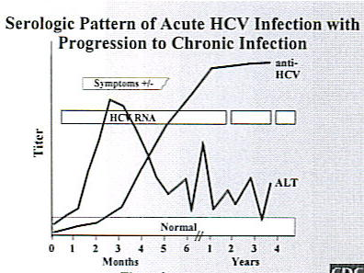
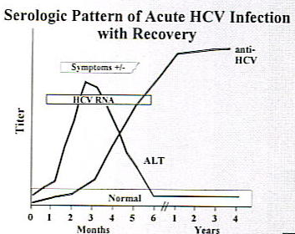

- Management 36:36
Prevention

- CDC has recommended primary and secondary methods for reducing the risk of HCV
- Primary- screen and test blood, plasma, tissue and semen from organ donors, risk-reduction counseling and services, and implementation and maintenance of infection control practices
- Secondary- identify patients who are HCV (+) and treat
- No vaccines available for prophylaxis
- Vaccine development is difficult because of extensive genomic variability of the viral mutants and the lack of efficacy of serum antibodies

Treatment
38:20
- Who should be treated?
- Patients seropositive for HCV (HCV RNA > 600IU/ml) with elevated ALT and inflammation/fibrosis on liver biopsy
  - Normal ALT does NOT exclude patients from treatment (ALT not reflective of severity of disease)
- Screening prior to treatment: cardiac evaluation, AFP (alfa fetal protein to rule out HCC), thyroid function tests.

- Goals of therapy
- Eradicate virus (achieve SVR)
  - Prevention complications of HCV infection
  - Stop viral replication
  - Slow progression of liver disease
- Minimize risk of hepatocellular carcinoma (HCC)
- Enhance QOL
- Prevent cirrhosis

Definitions

Rapid viral response (RVR) | patient with undetectable viral load at week 4 of treatment
Early virologic response (EVR) | patient who experiences at least a 2-log reduction in viral load by the 12th week of treatment (partial EVR) or a patient with undetectable viral load by the 12th week of treatment (complete EVR)
End of treatment response (ETR) | patient with no detectable viral load at the  end of treatment
Sustained virologic response (SVR) | patient with no detectable viral load at the conclusion of therapy and 24 weeks (6 months) later
Non-responders | patient with less than a 2-log reduction in viral load after 12 weeks
Partial responder | patient with at least a 2-log reduction in viral load but detectable viral levels after 24 weeks of therapy
Relapsers | patient who responds to therapy but whose viral load becomes detectable once therapy has been discontinued

Predictors of favorable response to therapy 00:00

- Genotype 2 or 3
- Low viral load (<1,000 IU/ml)
- Age (<40 years)
- Female gender
- Normal body weight

Treatment algorithm Prior to January 2014 3:22

- Genotype 1
  - Triple drug therapy
    - PEG-IFN plus ribavirin (total 48 weeks) plus telaprevir or boceprevir (total 12 weeks)
    - Telaprevir and boceprevir introduced in 2011. Prior to 2011, PEG-IFN and ribavirin x 48 weeks was the treatment of choice
- Genotype 2, 3 and others
  - Dual therapy
    - PEG-IFN plus ribavirin x 24 weeks

Drug therapy
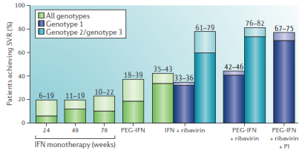

- Pegylated IFN-α2b (Pegintron®) and Pegylated IFN-α2a (Pegasys®)
- Know MOA 12:00 : Process of pegylation includes the attachment of inert polyethylene glycol to protein resulting in an increase net molecular size. This facilitates ↓ systemic clearance, ↑ exposure and allows less frequent administration of the product
- I combo with ribavirin
 | Pegintron ®  (Peg-IFN α2b) | Pegasys ®  (Peg-IFN α2a)
Drug Company | Schering | Roche
Approved for HCV | Jan 2001 | Oct 2002
Half life | 30-50 hrs | 50-80 hrs
Excretion | Kidney (30%) | Liver
Dosing | 1.5mcg/kg | 180mcg fixed dose
Storage | Room temperature | Refrigerated

- Ribavirin, (Rebetol® (capsule); Copegus® (tablet))
In combo with PEG
- Oral nucleoside analog with broad activity against viral pathogens
  - MOA not completely understood
  - Minimal direct activity against HCV replication
  - More likely inhibits/ depletes intracellular guanosine triphosphate which is necessary for viral RNA synthesis
  - May also have immunomodulatory effects

- Dual therapy: Peg-IFN and ribavirin
- Patients with genotype 2 and 3 have SVR of 75-85% compared to genotype 1 with SVR of 40-50%
- Only recommended in genotype 2 and 3 today
- Dosing
    - PEG-IFN subcutaneous once weekly PLUS ribavirin 400mg po bid x 24 weeks

Side effects of IFN and Ribavirin Therapy

PEG-IFN 12:30 |  | Ribavirin
Flu-like syndrome-  Bone marrow suppression  Help with NSAIDS or APAP <2g/day as prophylaxis |  | Hemolytic anemia (sudden onset of anemia can induce MI in patients with CAD or stroke in those with cerebrovascular disease)- all patients require cardiovascular w/u prior to initiating therapy  Patients may require ESA therapy
Neutropenia-GCSF as treatment
Thrombocytopenia

Psychiatric illness (depression, anxiety, irritability)- antidepressant as prophylaxis/treatment

Contraindications | Decompensated liver disease (TBili >1.5; INR>1.7, ascites, hepatic encephalopathy) | Pregnancy Category X  Renal dose adjustment necessary

New HCV Treatment Options- Direct Acting Antivirals (DAAs)
Four classes of DAAs 18:19

- NS3/4A protease inhibitors
- Boceprevir
- Telaprevir
- Simeprevir (approved 11/2013)
- Faldaprevir (under investigation)
- NS5B nucleoside polymerase inhibitors
- Sofosbuvir (approved 12/2013)
- NS5B nonnuclesoide inhibitors
- Deleobuvir (under investigation)
- NS5A inhibitors
- Ledipasvir (under investigation)

NS3/4A protease inhibitors 20:00
- The serine protease NS3/4A is used by the HCV for post-translational processing and viral replication. Inhibitors of this protein may lead to rapid decline in HCV but cannot be used as monotherapy due to rapidly developing resistance.

- Boceprevir and telaprevir are considered first generation NS3/4A. Only approved for genotype 1 patients- improved SVR to 70% compared to 50% with Peg-IFN and ribavirin alone

- RESPONSE GUIDED THERAPY (RGT)- meaning duration of therapy depends on patient’s response to treatment 20:45
  - Futility rules
    - HCV RNA < 25 IU/ml (undetectable) at wk 4; continue therapy with NS3/4A protease inhibitor
    - If HCV detectable >25 IU/ml at wk 4 or any treatment week thereafter, stop all treatment
- Genotype 1 23:50
  - Triple drug therapy
    - PEG-IFN subcutaneously once weekly PLUS weight based ribavirin (total 48 weeks) PLUS telaprevir 750mg po tid or boceprevir 800mg po tid (total 12 weeks)

Comparison between boceprevir and telaprevir for HCV genotype 1 disease
Characteristic | Boceprevir (Victrelis®) | Telaprevir (Incivek®)
Formulation | 200mg capsules | 375 mg tablets
Dosing | 800mg, 3 times daily  (7-9hrs apart) with food | 750mg, 3 times daily  (7-9 hrs apart) with food containing at least 20g of fat within 30 min prior to telaprevir dose
SVR, overall | 63-66% | 72-79%
SVR, partial responders | 40-52% | 54-59%
SVR, null responders | Not studied | 29-33%
SVR, relapsers | 70-75% | 83-88%
Characteristic | Boceprevir (Victrelis®) | Telaprevir (Incivek®)
Adverse events | Anemia (treatment options: ribavirin dose reduction, initiate ESA), neutropenia (consider GCSF), thrombocytopenia, dysgeusia (consider milk chocolate or lozenges), vomiting and diarrhea | Mild to severe rash (consider antihistamines, topical steroids, d/c drug for severe rash), anemia, anorectal itching and burning (consider fiber supplementation, loperamide, topical hydrocortisone, topical anesthetic), thrombocytopenia, GI events
Discontinuation due to AE | 10% | 5-13%

Drugs Interactions with Boceprevir and Telaprevir

Drug Class | Contraindication
Anticonvulsants | Carbamazepine, Phenobarbital, phenytoin
Antimycobacterials | Rifampin
Ergot derivatives | Dihydroergotamine, methylergonovine
Gi motility agents | Cisapride
HMG CoA reductase inhibitors | Lovastatin, simvastatin, atorvastatin
PDE5 inhibitor | Sildenafil, tadalafil
Sedatives | Triazolam, midazolam
Immunosuppressants | Cyclosporine, tacrolimus
Oral contraception | Ethinyl estradiol- decrease drug exposure. Two effective nonhormonal methods of contraception should be used

- Neither drug has been proven to be superior to the other
- Costs comparable depending on patient’s insurance plan
- Patient preference, side effects and insurance may determine which agent is prescribed

Recent drug approvals (Nov/Dec 2013)

- Simeprevir (Olysio®); NS3/4 protease inhibitor 3320
  - MOA: similar to boceprevir and telaprevir
  - Considered a second generation NS3/4A inhibitor
  - Approved as part of a combination regimen for the treatment of CHC in patients with genotype 1 disease
  - Simeprevir 150mg po daily + PEG-IFN + ribavirin x 12 weeks followed by 12 or 36 weeks of dual therapy with PEG-IFN + ribavirin
  - Simeprevir advantage: once daily oral agent and shorter duration of therapy than first generation NS3/4A inhibitors
  - Duration of dual therapy depends on whether the patient was previously treated or the extent of response to treatment.
  - Coadministration with moderate or strong inducers or inhibitors of CYP3A may affect drug levels
  - In patients with HCV genotype 1a infection, the presence of a naturally occurring NS3-4A protease polymorphism (Q80K) prior to
treatment was associated with a substantial reduction in SVR among patients treated with simeprevir. Q80K polymorphism testing is recommended prior to initiating therapy with this agent.
  - SE of simeprevir- rash, photosensitivity

- Sofosubir (Sovaldi®); NS5B polymerase inhibitor
  - Approved as part of a combination regimen for the treatment of CHC in patients with genotype 1, 2, 3 or 4 disease
  - First drug that CAN be used without IFN to treat genotype 2, 3 disease
  - Approved for co-infected patients (HCV and HIV)
  - Dose: 400mg po once daily
  - Genotype 1 or 4: Sofosubir + PEG-IFN + ribavirin x 12 week
  - Genotype 2: Sofosbuvir + ribavirin x 12 weeks
  - Genotype 3: Sofosbuvir + ribavirin x 24 weeks
  - Substrate for P-gp: coadministration with rifampin or St. John’s wort is contraindicated
  - SE of sofosbuvir: fatigue, headache

Future HCV options
- Once again we are preparing for a dramatic paradigm shift in approach to HCV infection
- Pursuit of all oral therapy is promising
- Cost considerations- current standard of care is $189,000 per SVR achieved (including need for ESA, transfusions, GCSF, hospitalizations etc.). New agents (simeprevir and sofosbuvir) estimated costs are $100,000 per treated patient. With improved SVR and reduced toxicities with new agents, total cost may decrease but that is yet to be seen.

Key points
- HCV is the most common cause of liver disease worldwide
- Progression to cirrhosis can take 20-40 years (chronic infection)
- MUST know genotype before selecting therapy
- Week 4 is crucial in determining likelihood of response in genotype 1
- SVR is defined as undetectable HCV RNA 6 months (24 weeks) after end of treatment
- NS3/4A inhibitors have a novel mechanism of action and can now be incorporated into triple drug regimens as initial therapy in patients with genotype 1
- Simeprevir: improved dosing regimen (once daily) compared to first generation NS3/4A and shorter duration of therapy (12 weeks) in combo with PEG-IFN and ribavirin. Q80K polymorphism testing should be done prior to the use of simeprevir.
- Sofosbuvir: First agent to show efficacy in IFN free regimen (i.e all oral regimen) and coinfection (HIV and HCV)
- Genotype 2: first approved, highly effective oral regimen consisting of sofosbuvir (IFN-free)
- Side effects of therapy are still a major obstacle to completion of tradition combination regimens
- ESAs like procrit and GCSFs like neupogen are often required during therapy with IFN.
- Must address issue of vaccinations (Hep A and Hep B) for all patients with chronic Hep C

General counseling tips for HBV and HCV

- Counsel patients to:
  - Use barrier protection during sexual intercourse
  - Avoid sharing toothbrushes or razors
  - Cover open cuts and scratches
  - Clean blood spills with detergent or bleach

Role of the clinical pharmacist

- Identify and educate patients who are at high risk and recommend screening
- Counsel on alcohol abstinence and the use of hepatotoxic drugs
- Recommend vaccination against hep A and B for those who are not immunized
- Counsel on side effect profile of all agents
- Encourage medication and lab tests adherence

Sample Exam Questions

- Treatment with one of the NS3/4A inhibitors (boceprevir or telaprevir) would be appropriate for which group of patients with chronic HCV infection?
  - Patients with genotype 2 or 3 HCV virus
  - Patients who are unable to adhere to therapy with pegylated interferon
  - Patients who did not respond to a previous trial of therapy with one of these protease inhibitors
  - Patients with genotype1 who did not respond to a previous course of PEG-IFN/ ribavirin therapy

Case Study

A 64 year old gentleman was recently diagnosed with chronic HCV infection.

SH: IV drug use/ snorted cocaine in his teens and 20s, multiple tattoos on his back and arms, heavy alcohol use in the past
Labs: ↑AST and ALT 133/244
HCV RNA level = 9,600,000 copies/ ml, HCV genotype 1a disease.
A liver biopsy performed 6 months ago revealed chronic hepatitis C with moderate inflammation and bridging fibrosis.
Q80K polymorphism- negative
Current medications: none.

- Which of the following is the MOST appropriate pharmacotherapy plan to treat this patient’s chronic hepatitis C infection?

- Simeprevir once daily + ribavirin sime must have peg
- Peg-IFN once weekly + ribavirin + sofosbuvir once daily (better than d)
- Sofosbuvir once daily + ribavirin good for genotype 2
- Peg-IFN once weekly + ribavirin + telaprevir three times a day

- As part of your counseling session you instruct the patient that one of the most common side effect of ribavirin therapy is?

- Depression
- Hemolytic anemia
- Neutropenia
- Suicidal ideation

- At week 4, the patient returns for a f/u visit and his HCV RNA level is undetectable. How would you define his response to therapy at this time?

- Achievement of the futility rule, therefore all medications should be discontinued
- Achievement of the futility rule, therefore switch to alternative NS3/4A inhibitor
- Achievement of a rapid virologic response (RVR), continue current regimen
- Achievement of a sustained virologic response (SVR)

